**FACULTY OF ECONOMICS AND ADMINISTRATIVE SCIENCES**

**CEN 302: SOFTWARE ENGINEERING**

**EPOKA UNIVERSITY**

Software Requirements Specification for Grocery Shopping App

Created by: “*ONE CLICK* “

MEMBERS:

Eria Dhespollari Amber Tepshi Armena Ballo Emla Kurti

Tirane, 7 June

**TABLE OF CONTENTS**

Contents

1. Introduction 1

1.1 Purpose 1

1.2 Document Conventions 1

1.3 Intended Audience and Reading Suggestions 2

1.4 Product Scope 2

1.5 References 3

2. Overall Description 4

2.1 Product Perspective 4

2.2 Product Functions 5

2.3 User Classes and Characteristics 6

2.4 Operating Environment 8

2.5 Design and Implementation Constraints 8

2.6 User Documentation 9

2.7 Assumptions and Dependencies 9

3. External Interface Requirements 10

3.1 User Interfaces 10

3.2 Hardware Interfaces 11

3.3 Software Interfaces 12

3.4 Communications Interfaces 13

4. System Features 13

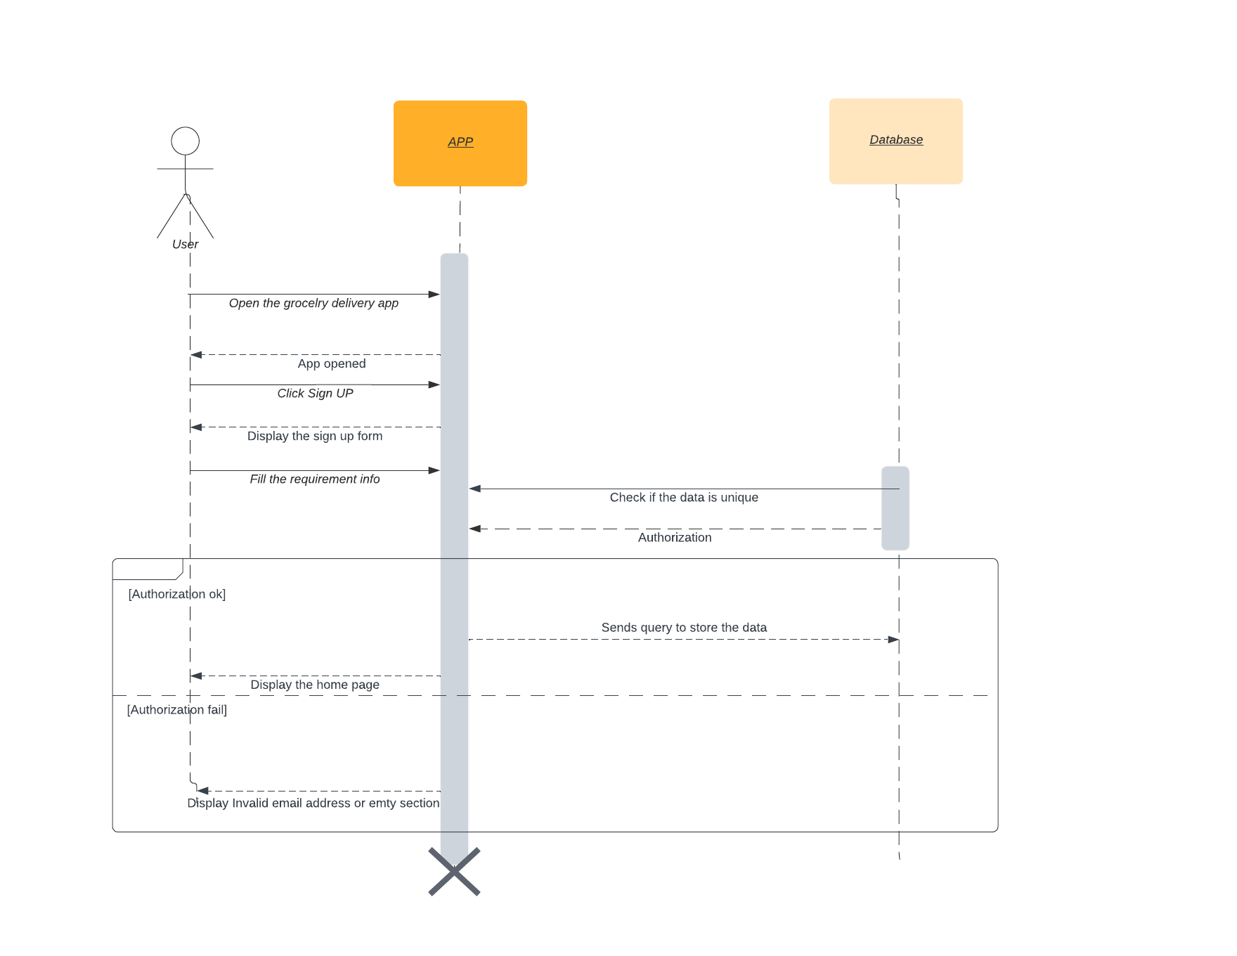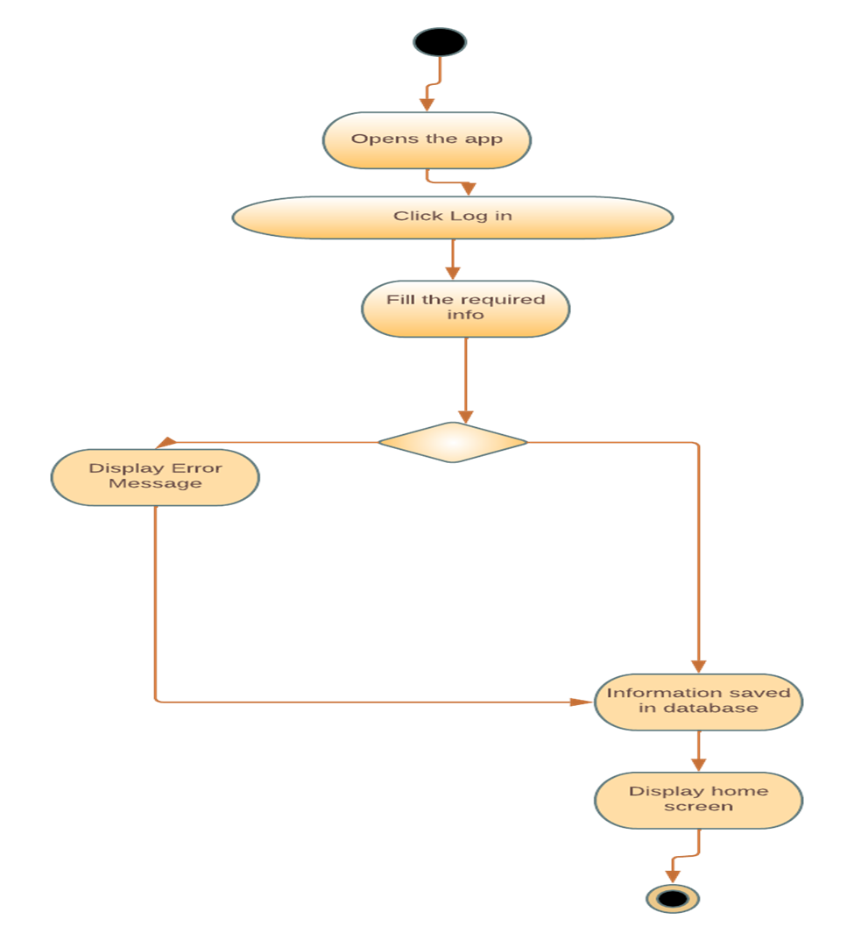 16

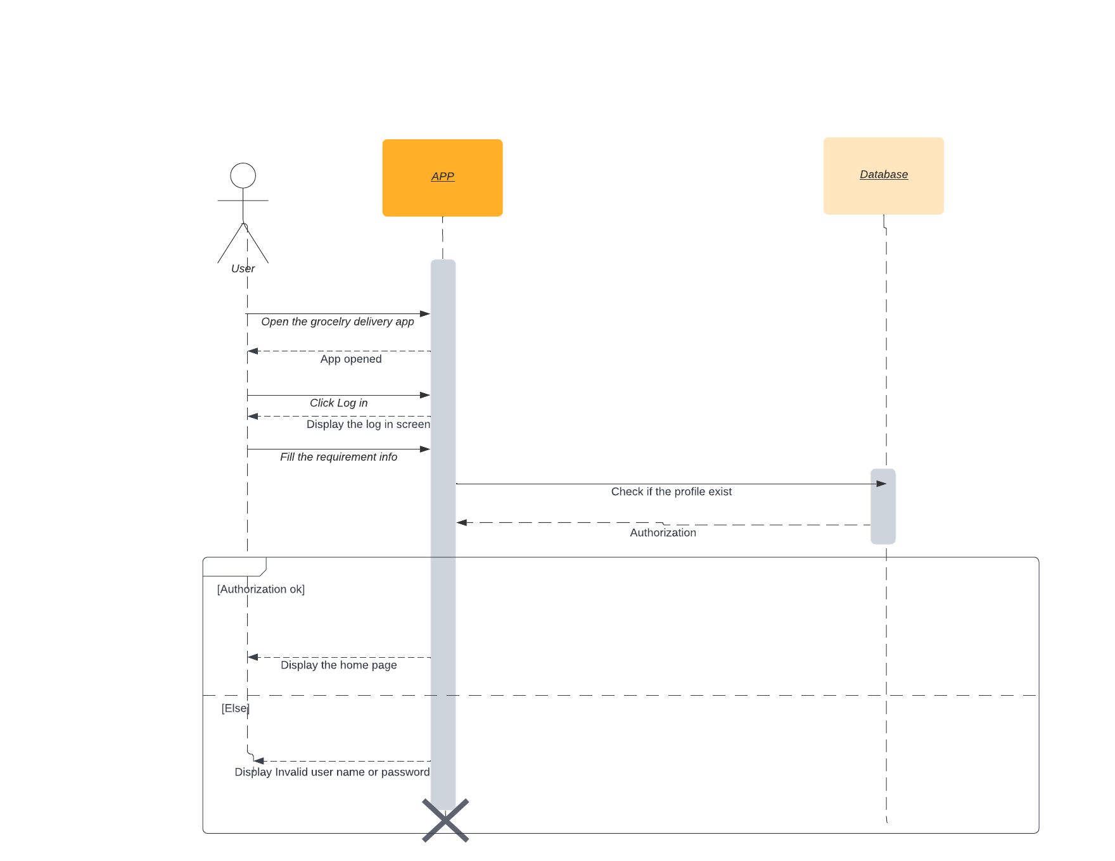 17

4.1 User Registration and Authentication 17

4.1.1 Description and Priority 17

4.2 Store and Product Catalog 18

4.2.1 Description and Priority 18

4.3 Shopping Cart and Ordering 19

4.3.1 Description and Priority 19

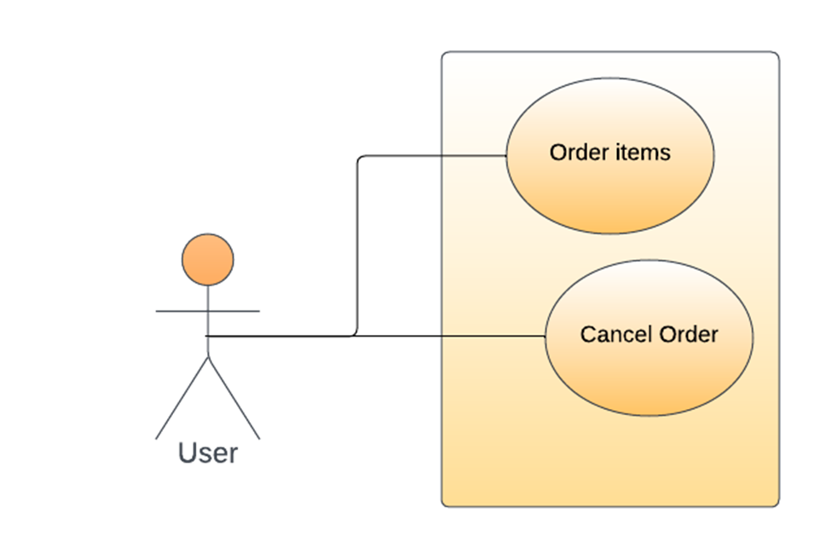 19

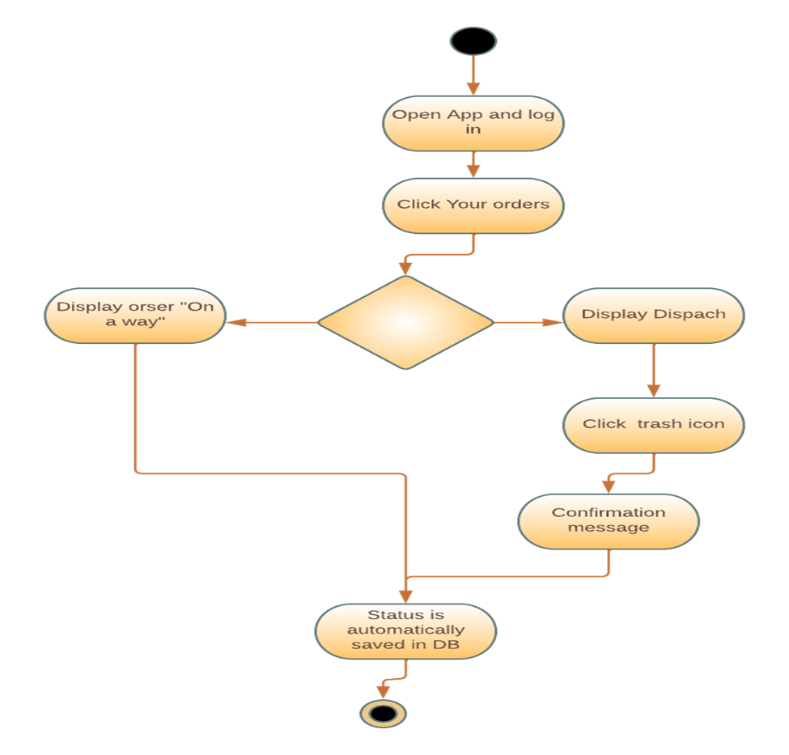 20

4.4 Order tracking 21

4.4.1 Description and Priority 21

4.5 Customer Support 22

4.5.1 Description and Priority 22

4.6 User Management 23

4.6.1 Description and Priority 23

4.7 Store Management 24

4.7.1 Description and Priority 24

4.8 Product Management 24

4.8.1 Description and Priority 24

4.9 Order Management 24

4.9.1 Description and Priority 24

5. Other Nonfunctional Requirements 25

5.1 Performance Requirements 25

5.2 Safety & Security Requirements 25

5.3 Software Quality Attributes 27

5.4 Business Rules 28

6. Other Requirements 28

# 

# Introduction

## Purpose

Every day in our daily routine people encounter difficulties or problems from the biggest to the smallest. The pace of life we have is quite intense, and often we don't have enough time to fulfill all our needs or tasks. Many people, due to their commitments during the day, often find it impossible to make various purchases by going to stores in person. We have heard a lot about online shopping and deliveries from clothing stores, restaurants, fast food, perfumery, etc. But what is missing, or more precisely is in a fairly limited number, enough to be counted on the fingers of one's hand, are the applications for the purchase and distribution of groceries.

In addition to good time management, another good thing that comes from opening this application is eating healthily. As mentioned above, people, due to the momentum of everyday life, order through online applications to eat during meals mainly foods harmful to health, or as they are otherwise called "junky foods". Therefore, one of the main goals of creating this application is to give people the opportunity to improve their diet and have a healthier physique. Moreover, this application provides convenience and comfort for people with or without a busy life.

## Document Conventions

**Font Styles**

* **Bold:** Used to highlight section headings, important terms, or key points.
* **Italics:** Used for emphasis or to differentiate examples, variables, or placeholders.
* **Monospace or Code Font: Used** for presenting code snippets, system output, or technical terms.

**Numbering or Labeling**

Requirements are numbered or labeled to provide a unique identifier for each requirement. This helps in cross-referencing and traceability. During the project we have used a lot of hierarchical numbering scheme like 1, 1.1, 1.1.1 which indicate the parent-child relationship between requirements.

**Tables and Lists**

Tables or lists are used to present structured information, such as functional requirements, non-functional requirements, or use cases. Columns or bullet points are used to organize and categorize the information.

**Highlighting or Colour Codes**

Certain text or sections are highlighted or color-coded to draw attention to critical or important information (mostly black colour)

Top of Form

## Intended Audience and Reading Suggestions

A grocery shopping app is a flexible tool that has something to offer many different kinds of users across various contexts. It is our considered opinion that utilizing a grocery shopping app can be quite advantageous for a wide range of people. This includes not only individuals, but also families and businesses; any group or organization that must buy groceries on a regular basis can benefit from such an app.

* **Individuals:** Nowadays, people are constantly balancing busy schedules. A grocery shopping application is perfect for those who struggle to find the time. They can browse and order items from the comfort of their homes, and have them delivered to their doorstep at the desired time.
* **Families:** Families nowadays can take advantage of the technology that provides a grocery shopping app, which represents a practical solution because it allows them to manage their purchases more simply and with ease. Through using this application, families get the benefit of creating shopping lists, tracking their orders and reordering their favorite items.
* **Seniors:** Seniors who, due to their age, cannot go out and do shopping while carrying heavy weights can choose to use this application in order to get their grocery shopping done. Without having to leave their homes, they can order groceries and have them delivered.
* **Businesses:** In the food service industry, restaurants, cafes and other businesses can optimize their efficiency by making use of modern technology. Specifically, they can turn to grocery shopping apps to order crucial items for their operations with ease and have these items delivered directly to them.

Some people who choose to use this application can not only help themselves but also their relatives, such as grandparents, by ordering items for them and having them delivered to their home address.

## Product Scope

The product scope of this application is to provide a comfortable and easy shopping experience to users, where they can effortlessly browse through different products, create shopping lists and get everything delivered, all from the comfort of their own home. It typically includes:

* **User Interface:** A top priority when it comes to the app's interface is user-friendliness. This means that the design and organization should be natural; making it easy for users to navigate through different features and functions.
* **Product Catalog:** Users of the app should be able to select from a wide range of locations depending on their home address or perhaps a desired store in another neighborhood. They should also be able to select products from different categories like fruits and vegetables depending on what the stores offers, all in the app's comprehensive product catalog.
* **Shopping list:** Users should be able to make and save shopping lists through the app, which they can then simply modify and reuse for future purchases.
* **Payment Gateway:** The application needs to feature a safe payment gateway that enables users to pay with different methods like credit cards or cash in hand when the grocery arrives at their destination.
* **Delivery:** When checking your order, the app shows updates made by admin about the status of your delivery.
* **Customer Support:** To respond to user questions and issues, the app should offer dependable customer care channels like email help.

## References

1. <https://oyelabs.com/grocery-delivery-apps-business-models/> (Business Model/Hyper-local Marketplace)
2. <https://progressivegrocer.com/grocery-delivery-consider-legal-ramifications> (Regulatory Compliance)
3. <https://www.indeed.com/career-advice/career-development/preventive-action> (Preventive actions)

# Overall Description

## Product Perspective

The app's overall perspective, place in the market, and compatibility with user requirements are all referred to as the "product perspective" of a grocery shopping app. This application is totally new and a needed novelty to the market. Firstly, it is essential to understand the user's needs and behavior. Secondly, developing a sustainable business model that complies with the required regulations is crucial for long-term success. Below are some important aspects of this product:

* **User Needs:** The app offers meets the needs of the user by offering a different range of stores and products, simple navigation, secure payment and reliable delivery.
* **Market Analysis:** A grocery app comes in need to people from different age groups and backgrounds. It adapts to the users need by offering him a wide range of products. Considering it is still an innovative idea we feel that it will be very successful in the market as people have become more and more accepters of new technology that conveniences their life.
* **Technology:** The app is user-friendly and comprehensive by all ages. It has been developed by using languages like php, html, javascript and css for its design. The app is available to access through your browser.
* **Software Process Model:** We intend on using the waterfall model to develop this application. This is a plan-driven model that includes these phases:

1. Requirements analysis and definition
2. System and software design
3. Implementation and unit testing
4. Integration and system testing
5. Operation and maintenance

Despite choosing this model we decided to incorporate elements from other software process models as well to ensure the best quality product.

* **Regulatory Compliance:** The application will obviously comply with the relevant laws and regulations, such as data protection and payment processing. Some of these regulations are:

1. **Payment Card Industry Data Security Standard (PCI DSS)** - Businesses that accept credit card payments are required to adhere to the PCI DSS security standards. These requirements must be met by the grocery shopping app in order to protect the privacy of financial transactions.
2. **General Data Protection Regulation (GDPR) -** The European Union's (EU) GDPR is a rule that controls how people's personal data is processed. The grocery shopping app must adhere to GDPR regulations if it collects, stores, or otherwise processes the personal data of EU people.
3. **Food and Drug Administration (FDA) -** The FDA's rules for food safety, labeling, and packaging must be followed by the grocery shopping app if it offers food products.
4. **Federal Trade Commission Act (FTC Act) -** The FTC Act is a law that forbids unfair and dishonest business activities. The grocery shopping app needs to make sure that its customer-facing business procedures are just and open.

*The major components of the system are shown in the diagram below:*

Typically, the application layer sits between the data storage layer and the user interface (UI). Receiving requests from the UI, processing those requests, and producing responses to send back to the UI are all the responsibility of the application layer. This layer frequently consists of a number of interconnected subsystems that cooperate to provide the functionality unique to each application, such as order administration, product management, payment processing, and delivery management.

## Product Functions

**Customer App Functions**

1. Profile Creation
2. Store and Product Selection
3. Order Placement
4. Payment Processing
5. Order Tracking

**Admin Panel Functions**

1. Registration
2. Content Management
3. Order Management
4. Dashboard
5. User Management

## User Classes and Characteristics

**Customer App Features**

1. **Profile Creation**

This will be the first step users take when they open your app, to create a profile. Users will need to monitor their orders, make payments, and more, so it is crucial. The user will be able to input the necessary information into the app when registering. When desired the user can log out of the account.

1. **Store and Product Selection**

One of the most noticeable and important aspects of a grocery delivery app is this one. Once logged in, the user can select the store in which they would like to shop. There he can find a variety of products according to their need. The price inputted for the price is the price for 1kg of product. After choosing their desired shop they can choose different products which will be added to the cart and then proceed to checkout.

1. **Add To Cart Option**

This is among the most crucial aspects that any app for shopping or purchasing groceries needs to have. You cannot anticipate them to place an order from a single location, finish the order process, pay the retailer, then proceed to the next location to place an order, and so on. To allow users to choose all of their things from whatever location they like, put them to a cart, and then place their order all at once, a cart option is offered. Moreover, shoppers occasionally add products to a basket but finish the order the next day or at another time. A cart makes sure that the chosen items are saved in one place and that the order can be finished whenever the client is prepared to do so.

1. **Payment Gateway**

The users' order has been placed, and now it's time to finish the transaction by checking out. A significant component is payment. Since Albania is still kind of traditional the only option available is to pay up when you receive the delivery. However, when the delivery is received you can pay by cash or credit card.

1. **Order Tracking**

Through this function the customer can keep track of his order real-time status. It entails keeping track of how the order is progressing through the various steps of delivery, for example they let the customer know if the product is on its way, it was rejected or everything has been completed so the order is closed. Customers benefit from receiving accurate and current information about their orders in this way.

1. **User Management**

Admin can add a new user or even delete them based on their activity. For example, if the policy allows it he can even delete users who were inactive for more than a year.

**Admin Panel Features**

1. **Registration**

Similar to the client-side app, the admin panel also needs. The many admins can register with your company and use this panel to manage their data. They have the ability to add new products, update their existing ones, alter prices, and more.

1. **Content Management**

With the aid of this function, you may improve the user experience by updating and managing the content. The choices to control the material often include:

* 1. Edit information about the grocery store, such as the name, address, phone number, and hours of operation.
  2. Add images
  3. Product list editing (example – deleting items, changing the price)

You are assisting users in having a better UX from your grocery platform by keeping the information current and in real-time.

1. **Order Management**

The order management tool aids retailers in managing order receipt and delivery. The grocery retailers can use this capability to manage order status and inform clients when their orders will arrive at their doorstep. They can also remove orders when needed.

1. **Dashboard**

An essential component of the overall user experience for the admins' app is the dashboard. Dashboard is the homepage the admin user will be greeted with when logging in. There he can easily access the number of stores, products, orders and customers.

In a grocery shopping app, the following relevant traits of each user class are listed:

1. **Customers:**

* They are the app's intended customers, and when they buy for groceries online, they often look for convenience and usability.
* They could have varied dietary limitations, shopping preferences, and delivery choices.
* They anticipate being able to swiftly and securely identify the products they require, check pricing, and place orders.

1. **Administrators:**

These are the people that insert the goods that are offered from different stores through the grocery shopping app.

* They could offer various products and employ different pricing and delivery methods.
* They anticipate being able to efficiently fulfill orders, update product details and pricing, and manage their inventory with ease.
* They are responsible for the main components such as the users, the orders, the stores and the items.

## Operating Environment

When developing a grocery shopping app, it is important to consider the environment in which the software will operate. Specifically, this means taking into account key considerations such as hardware platform and operating system versions.

1. **Hardware Platform**

When considering the hardware platform on which your app will run, it is important to ensure that it can operate smoothly on a variety of devices; this includes smartphones and tablets with varying specs like processor speed, RAM capacity and storage size of memory.

1. **Operating system**

To ensure widespread availability and accessibility of the grocery shopping app, it is essential that it be developed to run on popular operating systems such as Windows. In fact, the app should be designed to accommodate both newer and older versions of these operating systems in order to cater to users who are using older devices.

1. **Other software components or applications**

Compatibility with different software components or applications, such as web browsers, is also crucial for seamless functioning. As a result, developers must take extra care in ensuring that the grocery app runs smoothly with these components and applications.

There are additional factors that the grocery shopping app developers need to consider, apart from hardware and software requirements. The app should also factor in network and security specifications to ensure user protection. It is essential for this app to function across diverse network connections, which include not only Wi-Fi but also cellular data. Furthermore, the developers should prioritize incorporating security features into the design as a measure against potential risks that may compromise users' sensitive information.

## Design and Implementation Constraints

There exist several items and issues that may serve as hindrances to the options accessible to developers creating a grocery shopping app. These factors are:

1. **Regulatory compliance**

Due to various laws surrounding data privacy, payment regulations, and food safety rules, certain technologies and tools may become unavailable for use in constructing the app.

1. **Hardware limitations**

Hardware limitations consist in requiring specific hardware requirements to be met for the app to function properly. These requirements may include minimum processor speed, memory requirements, or camera resolution if the app includes scanning functionalities.

1. **Interfaces to other applications**

Developing an app requires adherence to specific protocols and APIs in order to interface with other applications or systems such as payment gateways, delivery tracking systems or inventory management systems. This may limit the options available to the developers for creating interfaces that properly work within the given architecture.

1. **Security considerations**

Security is of utmost importance in app design. Therefore, developers must take into consideration secure data storage, encryption, and access control when building an application.

1. **Design conventions and programming standards**

The customer's organization may have strict design conventions and programming standards that need to be followed. This factor can limit the development team's choices when designing and coding the application.

1. **Language requirements**

If the app needs to be available in multiple languages, then certain frameworks or libraries may not be suitable for development.

1. **Budget constraints**

When working on the development of an app, budget constraints can often limit the options available for technologies, tools, and development approaches. Unfortunately, this can often mean that developers must choose between practicality and innovation when deciding which direction to take their work in.

## User Documentation

The user documentation for the grocery shopping app will comprise several components.

1. **User Manual**

A user manual is a comprehensive guide explaining how to use the application. The manual will provide in-depth instructions on all of the app's features and functions, including but not limited to creating an account, selecting products, adding items to cart, making payments and tracking orders.

The user documentation for the app will be made available in a digital format. It is designed to be user-friendly, with clear language and illustrations that make it easy to navigate the various features and functions of the app. It will be delivered along with the software.

## Assumptions and Dependencies

Assuming the implementation of a grocery shopping app, there are several potential factors that could impact the requirements stated in its Software Requirements Specification (SRS).

1. Availability of third-party APIs for location tracking, payment gateways and other such functionalities is an important consideration to keep in mind.
2. The smooth functioning of the app would also depend heavily on internet connectivity and network availability.
3. User acceptance is another key factor to consider given their willingness to adopt new technologies for online grocery shopping.
4. Admins' consistency and precision in sharing data pertaining to accessibility of products and the pricing are essential factors.
5. The scalability of the app is important so that it can endure heavy traffic from numerous users at peak hours without crashing.
6. Ensuring security against cyber-attacks, fraudulent activities, and safeguarding user data must be taken into account as well.
7. Compatibility with various operating systems on diverse hardware such as desktops, tablets, and mobile phones stands paramount.
8. It is also necessary to abide by legal and regulatory requirements for online grocery shopping which encompass tax policies, privacy guidelines, and laws that protect user information.

Dependencies on external factors include:

1. Availability and compatibility of software components and APIs, the timely delivery of hardware components like servers, routers, and switches.
2. Abundance of competent developers required for software development and testing purposes.
3. Complying with industry regulations like PCI-DSS and ISO 27001 remains mandatory if you wish to achieve your objectives.

Collaborating with stakeholders from vendors, delivery services to payment gateways may prove pivotal in achieving a streamlined experience

# External Interface Requirements

## User Interfaces

1. **Buyer Interface:**

* The buyer interface will have a graphical user interface (GUI) that is both user-friendly and aesthetically pleasing.
* A home page with featured goods, a product detail screen, a shopping cart screen, and an order tracking screen are a few examples of sample screen images.
* Consistency in design components including fonts, colors, icons, and layout will be maintained by adhering to GUI standards and product family style guides.
* The screen layout will be created with the most important information prioritized, making it simple for customers to browse and choose products.
* On the relevant screens, common buttons and options like "Home," "Your orders," "Shop," and "Sign in/ Log out" will be present.
* In order to give consumers clear and actionable information in the event of any problems or input errors, error messages will adhere to a uniform format.

1. **Admin Interface:**

A grocery shopping app's admin interface gives administrators or support staff the tools and functions they need to administer and keep an eye on the application's general operation. The admin interface has the following significant features:

* **User Management:** Using the admin interface, administrators can create new user accounts, update user information, and address any account-related concerns. Features like user registration, authentication, and password management may be present.
* **Store Management:** Administrators have control over the shops and merchants listed on the app. They can manage any store-related settings or setups, evaluate and approve vendor registrations, and confirm vendor information.
* **Product Management**: The admin interface has tools for managing the platform's available products. Administrators have the ability to add new items, edit existing product information, classify products, control pricing, and manage inventories.
* **Order Management:** Admins can view and follow orders placed by customers thanks to order management functionalities that are accessible to them. They can handle cancellations or refunds, oversee order fulfillment, keep track of order statuses, and engage with vendors and customers about problems or questions relating to orders

In order to facilitate interaction and offer a seamless user experience, numerous software components in a grocery shopping app need a user interface. The software parts that generally demand a user interface are as follows:

* **Home Screen:** The app's primary screen, which gives users an overview and acts as their entry point. It might provide navigational choices, search features, featured products, and specials.
* **Product Listings:** The user interface for displaying a list of the supermarket items that are currently on offer. Users can use it to explore, search, filter, and sort things according to their needs and preferences.
* **Product Detail Screen:** The user interface that offers comprehensive details on a particular product. It contains pertinent information such as product photos, descriptions, prices, and nutritional data.
* **Shopping Cart:** Users may view and manage the products they have added to their cart using the shopping cart interface. Users can change amounts, delete goods, and then finish the checkout process.
* **Checkout and Payment:** The interface enabling consumers to review their chosen items, choose a payment option, and securely complete the purchase when the goods are delivered.
* **Order tracking:** The user interface that lets users to examine expected delivery timelines, follow the status of their orders, and get alerts or updates on how their orders are progressing.
* **User Account Management:** Users can create accounts, log in, update personal information, and through them access the related features.

## Hardware Interfaces

**Logical Characteristics:**

The logical characteristics specify how the software and hardware interact, exchange data, and control operations.

* **Input and Output:** The logical properties specify how the software product communicates with the hardware elements to accept input and output data. This includes tools for obtaining user input (using a keyboard, mouse, touch screen, or voice recognition), as well as tools for providing output (displaying data on a screen or creating audio output).
* **Data Format and Protocols:** The logical attributes specify the data format and protocols that are used to exchange data between the hardware and software components. To ensure smooth data transfer, it is necessary to establish the data structures, data types, encoding techniques, and communication protocols.
* **Command and Control:** The logical properties describe the manner in which the software product issues commands and manages the hardware elements. Here, the orders or instructions that the software can issue to the hardware to carry out particular tasks or processes are defined.
* **Error Handling:** The software product's logical characteristics specify how it recognizes and responds to errors or unusual circumstances that may occur during interactions with the hardware elements. This covers systems for detecting faults, error messages or codes, and steps for politely handling mistakes.

**Physical Characteristics**

The physical characteristics include the physical connectors, compatibility, performance considerations, and scalability aspects that allow the software to effectively interface with the hardware components.

* **Hardware Interfaces:** The actual physical connectors, ports, or interfaces that the software product uses to communicate with the hardware components are included in the category of physical characteristics. This comprises physical connections such as Ethernet ports, HDMI or VGA display interfaces, audio connectors, USB ports, and other interfaces.
* **Compatibility:** The physical qualities take into account the needs for software and hardware component compatibility. This entails making that the device's architecture, operating system, drivers, and any particular hardware dependencies or requirements are all met by the software.
* **Performance Considerations:** The hardware components' performance elements are taken into account when determining the physical specifications. This includes taking into account factors like processing speed, memory needs, disk space, network bandwidth, and other hardware-specific constraints that could affect the performance of the software.
* **Scalability and Expansion:** The physical qualities speak to the software product's capacity to grow and adapt to changes in the underlying hardware. This includes thinking about how to accommodate extra hardware, how to deal with hardware upgrades or replacements, and how to make sure the program can adjust to changing hardware configurations.

## Software Interfaces

* **Databases:** The grocery shopping app is connected to a database management system (DBMS) to store and retrieve data. This DBMS is PHPMYADMIN.
* **Operating System:** The grocery shopping app may be developed to run on specific operating systems such as Windows, macOS, Linux, Android, or iOS. The specific version would depend on the target platforms and the app's development requirements.
* **Tools and Libraries:** The app utilizes various development tools and libraries for building specific features. For example, it uses programming languages like JavaScript for its interaction, CSS for its styling. HTML for its structure and PHP for its connection and other features. Additionally, frameworks have been employed. There have been many fonts included.

**Incoming Data Items/Messages:**

* **User Registration:** When a user registers on the app, the system receives personal data from them to create a new user account, such as name, email address, and contact information.
* **Product Listings:** The app obtains product information from a database within the system or from an outside source. This information includes details on the product name, description, cost, as well as photographs.
* **Order submission:** Customers place orders by choosing products and entering information about the order, including the quantity of each item, and the method of payment. The system receives these order details for processing.

## Communications Interfaces

Depending on the unique features and functionalities, the requirements for communications operations in a software product, such a supermarket shopping app, can change. The following are some typical communication needs:

* **Support for Web Browsers:** The program could need to interact with web browsers for a number of reasons, including displaying web pages, gaining access to outside resources, or integrating with web-based services. The specifications might include support for HTTP (Hypertext Transfer Protocol), compatibility with well-known web browsers, and conformance to web standards.
* **Communications with Network Servers:** The app may speak with network servers to retrieve data, carry out authentication, or synchronize data. Support for particular network protocols (such TCP/IP), data transfer rates, error management techniques, and dependable communication methods may all be needed.
* **Electronic Forms:** The app may employ electronic forms, such as registration forms, address forms, or feedback forms, to collect user input. Data validation, form submission processes, data transfer security, and adherence to form data standards are a few examples of the needs that could be present.
* **Data Transfer Rates:** When transferring significant volumes of data, such as product photos, papers, or multimedia material, the app may have data transfer rate requirements. Acceptable transfer rates, data compression methods, and effective data transfer mechanisms could all be mentioned in the specifications.

# System Features

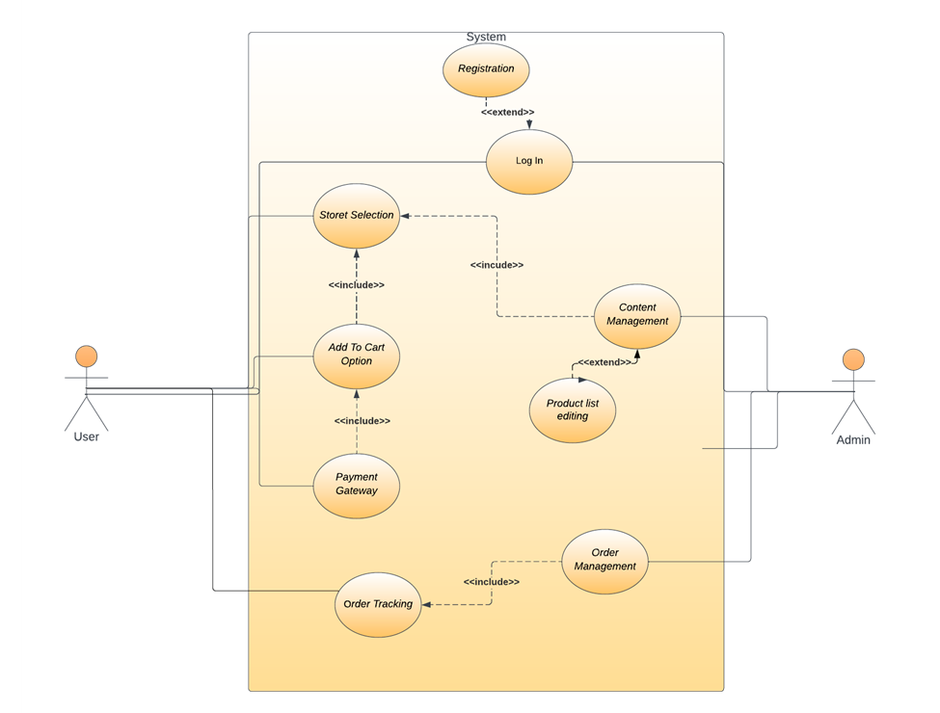

Regarding customer:

***Functional Requirements***

1. The app should provide an intuitive and user-friendly interface for easy navigation and product discovery.
2. The app should support smooth and secure processing.
3. The shopping cart should maintain accurate product quantities and update prices.
4. The app should provide real-time order tracking to keep customers informed about their orders.
5. The app should ensure data privacy and security, protecting customers' personal information.
6. The customer support feature should be easily accessible, allowing customers to seek assistance or resolve any issues promptly.

User Registration and Authentication

* Allow users to register for an account.
* Provide secure authentication checking if the user is registered in the database.

Store and Product Catalog Management:

* Display a comprehensive catalog of grocery items.
* Include product details such as name, description, and price.

Shopping Cart and Ordering:

* Allow users to add items to their shopping cart.
* Enable users to modify quantities and remove items from the cart.
* Support various payment options, such as credit cards, digital wallets, etc on delivery.

Order tracking

* Allow users to track their order’s status.

Customer support

* A phone number or email will be available in the website for the user to contact regarding any inconvenience or problem

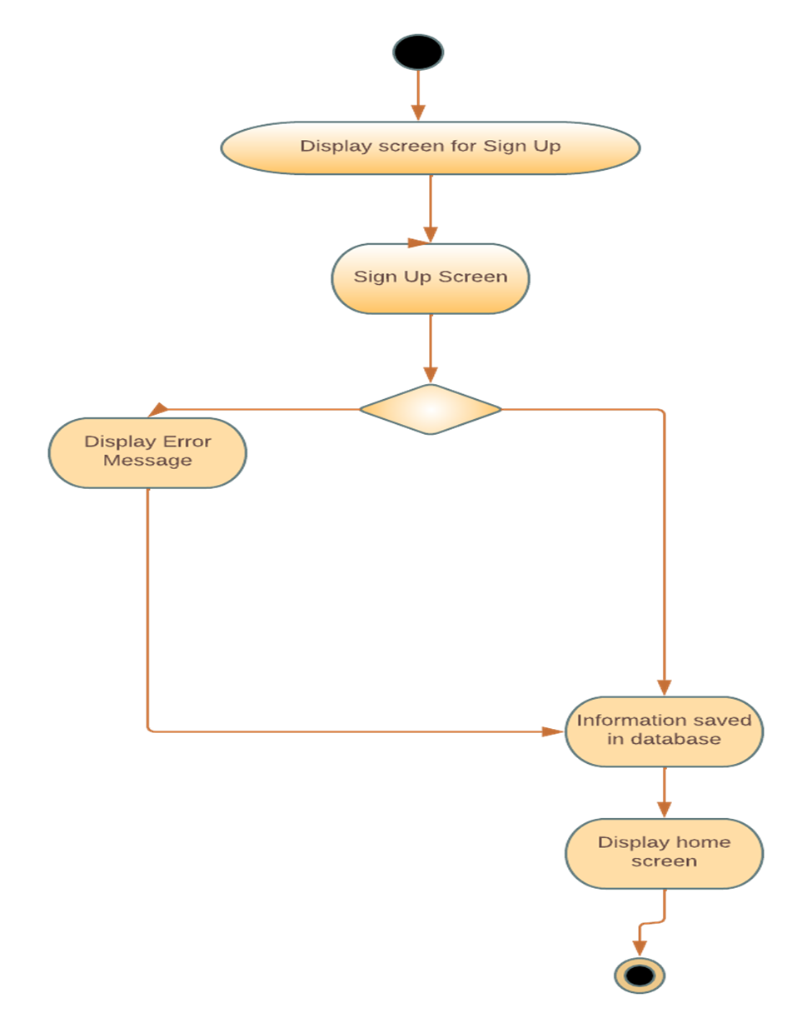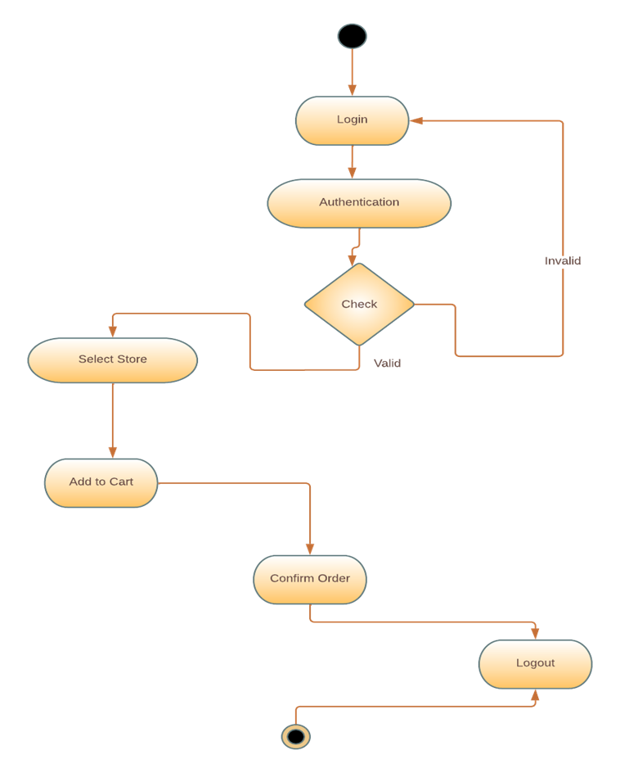

## 

## 

## 4.1 User Registration and Authentication

### Description and Priority

In order to allow for secure access to an application, one of the primary elements required is user registration and authentication. Allow us to explain what these terms mean:

**User Registration:**

* When individuals want to create a new account in a system, they go through the process of user registration. This requires users to enter necessary information such as a username, email address along with choosing their own passwords.
* As part of this process, the system verifies that input fields for email addresses and usernames provided by prospective users are inside the decided rules.
* Apart from these mandatory details, other information like phone number& location has to be entered during this stage as well.
* Once successfully registered on the application they have created their accounts within the system's database, using their previously chosen credentials.

**User Authentication**

* It is essential that before given access into a secured application or a platform service provided by any organization — it necessitates going through an identity verification procedure known as 'user authentication'.
* During login time when users access websites/applications with their respective credentials; the authenticity of said credential details are being validated by comparing it against registered users stored in Database

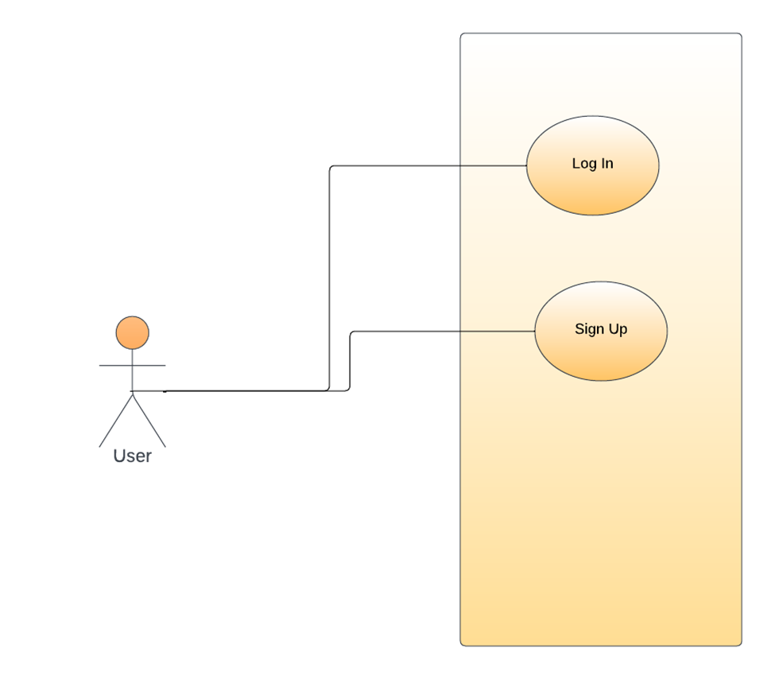

**4.1.2 Stimulus/Response Sequences**

<List the sequences of user actions and system responses that stimulate the behavior defined for this feature. These will correspond to the dialog elements associated with use cases.>

(Tabela)

## Store and Product Catalog

### Description and Priority

Within the context of grocery shopping apps, users can readily browse through an array of available products by utilizing the Store and Product Catalog feature. While browsing, users can discover essential information about each item in order to make well-informed purchasing decisions. Here's how it works:

**Store Selection**

The user has access to a list of store options within the app and can select their preferred store based on preference specifics. Relevant details such as operating hours may be provided.

**Product Browse**

When the user chooses the store, he is met with a variety of products he can choose from. Most of the time these products are quite obvious as they match the theme or category the store the user chose is in. The product is constructed with a name, description and price.

## Shopping Cart and Ordering

### Description and Priority

In a grocery app, Shopping Cart and Ordering are crucial features that allow users to pick and buy the products they want. Here's a detailed overview of how these features work:

The first function is Shopping Cart. This lets users select items they wish to purchase from the store catalog by clicking on an "Add to Cart" button beside each product. They can then modify item quantities or delete items at any time, while the cart displays pertinent information like prices and subtotals.

Ordering follows once the user has added items in their shopping cart. Before finalizing purchases, customers will be able to closely evaluate what's currently in their carts by reviewing important details presented. Payment method options include credit/debit card payments or even cash all on delivery.



## 

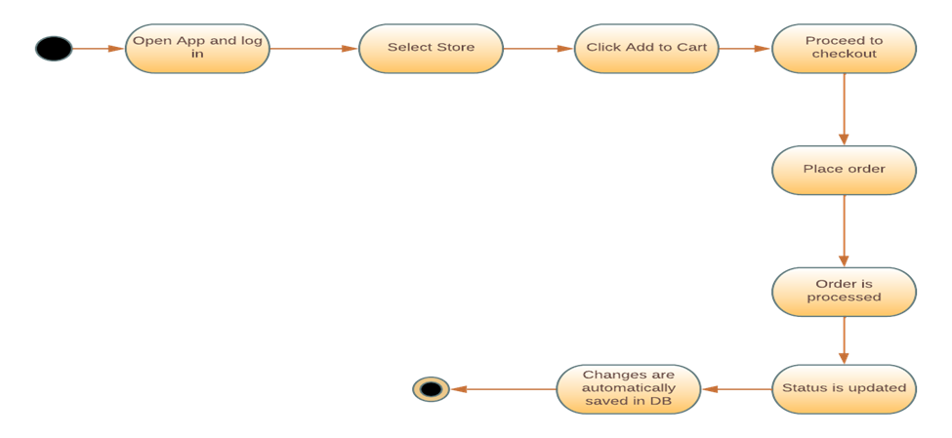

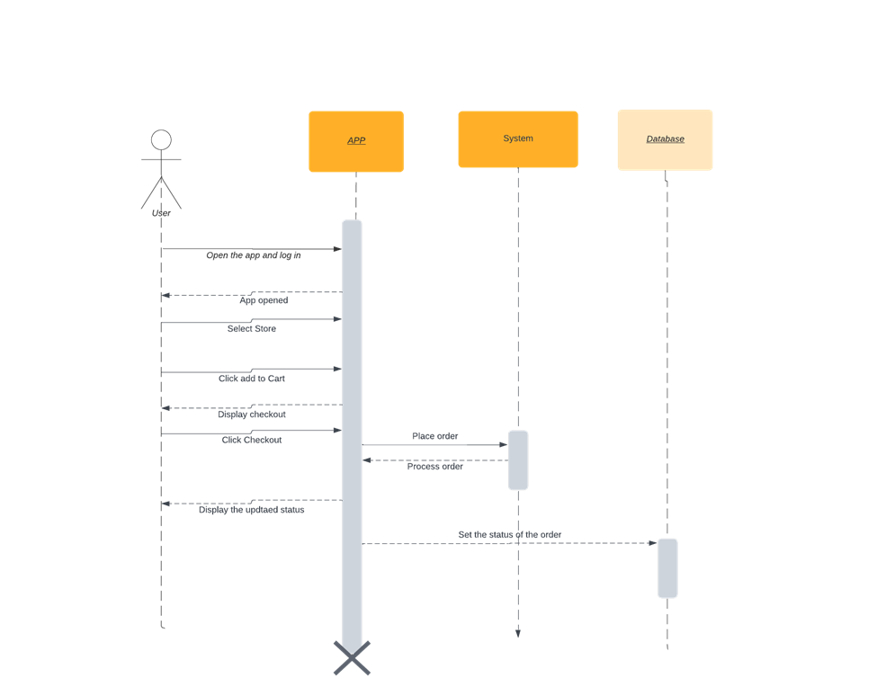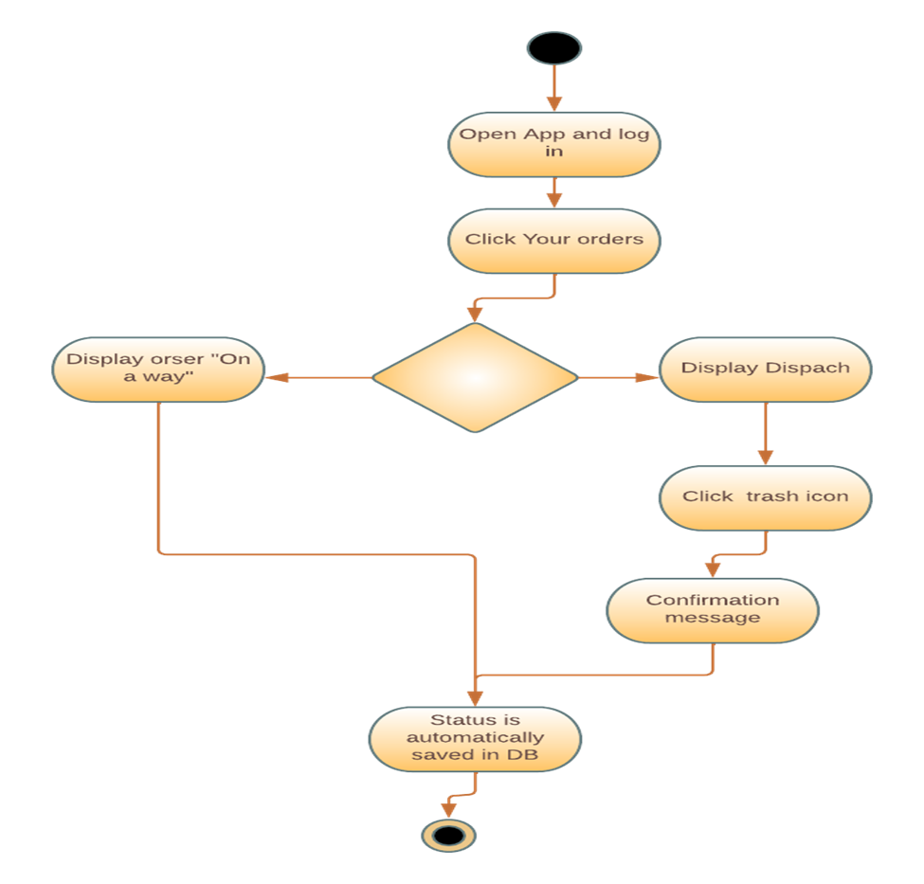

## 

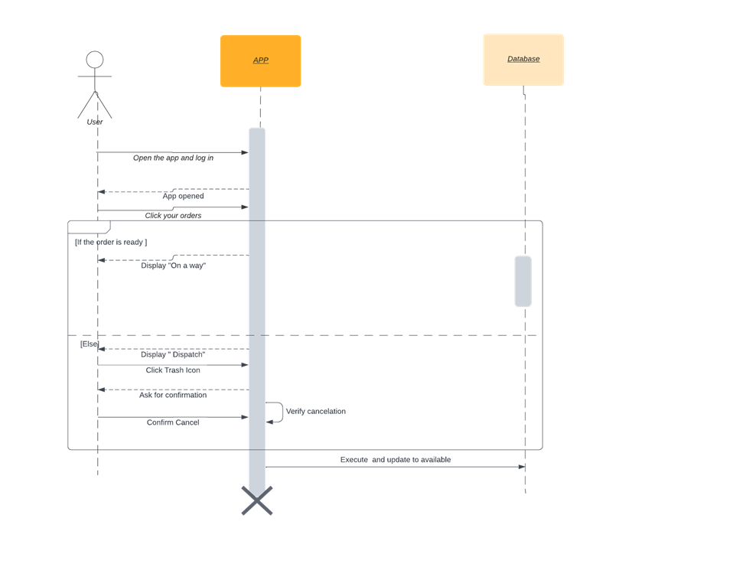

## Order tracking

### Description and Priority

Order tracking is a useful feature found in grocery apps that enables customers to monitor and receive updates on the status and progress of their purchases from start to finish. This important convenience provides real-time information for users regarding the status of their orders, as well as ensures transparency in the shopping experience. The order tracking process consists of several stages which go as follows:

Firstly, after an item is ordered through the designated grocery app, an order acknowledgement will be generated confirm that the order has been successfully issued.

Once confirmed through the backend processing system within the app, groceries are checked against inventory well before packaging commences by verifying corresponding items matching uniquely prepared checks then performing preparation required for successful deliveries.





## Customer Support

### Description and Priority

Despite not offer in-chat support, the users are provided with an email and phone number they can contact for any inconvenience or problem they might have regarding the store, the order, or their account. Users can contact a designated customer support ready to assist them. Through these channels, the support team answers to questions, offers assistance, and addresses problems.

Regarding admin:



**User Management:**

* The admin should be able to create, modify, and delete user accounts.
* User authentication and password management should be included.

**Store Management:**

* The admin should have the ability to manage store information.
* This includes adding new stores, updating store details (such as location and operating hours), and deactivating or removing stores if needed.

**Product Management**

* The admin should be able to manage the product catalog.
* This involves adding new products, updating product details (such as name, description and price), and removing or deactivating products.

**Order Management**

* The admin should have access to order management functionalities.
* This includes viewing and tracking orders and managing order status (such as confirming, canceling, or dispatching orders).

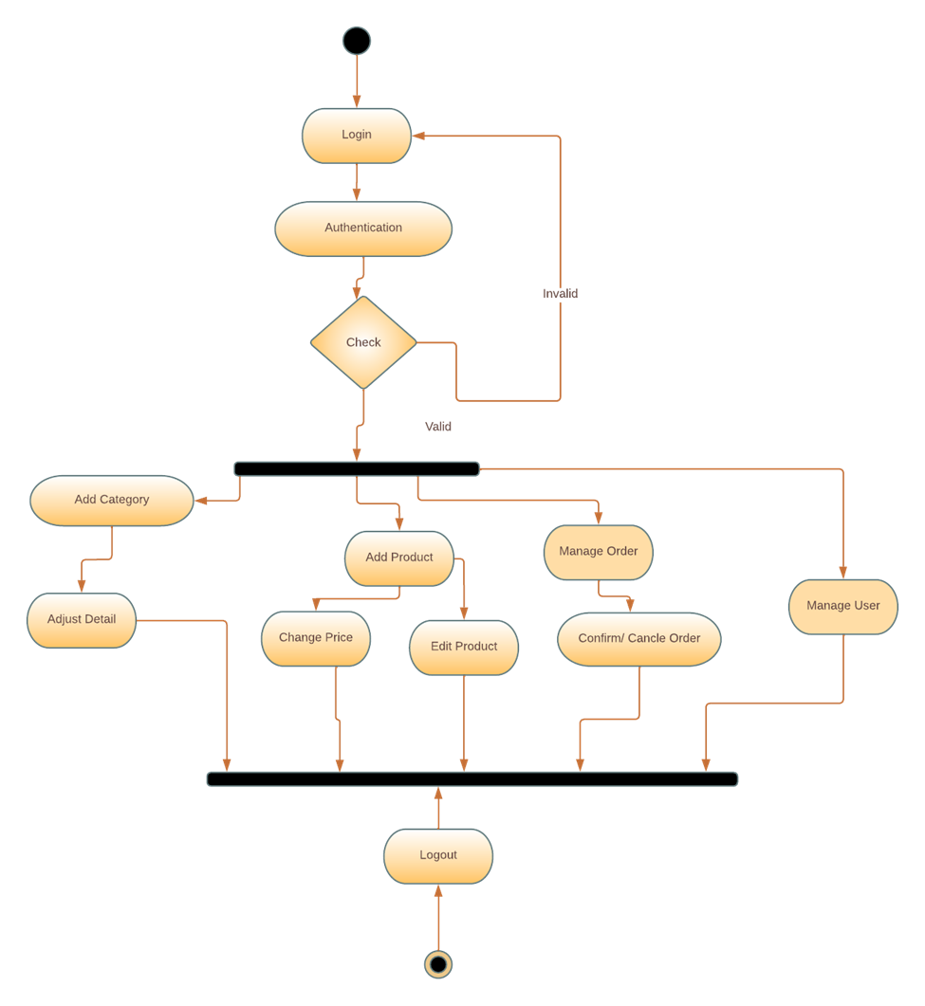



## User Management

### Description and Priority

The admin has the ability to modify users’ input based on their request. They can remove inactive users if needed or even add new ones. They can see all the users and their personal information. This information is also stored on the database. Any change made by the admin makes and saves changes in the database as well.

## Store Management

### Description and Priority

Admin can add new stores when a new business decides to be part of this application. They can delete the stores that wish to leave this platform. And they can also edit the information about a store if they for example relocate or decide to change their phone number or opening and closing hours. Basically, they can manage all the information about the stores down to their products.

## Product Management

### Description and Priority

The admin can see all the products available in stores. He is responsible for adding these products. The admin can add new available product or update existing information. He can also delete products that are no longer supported by the store. Basically, admin manages all the products. Everything is connected to a database and changes made are automatically saved there as well.

## Order Management

### Description and Priority

Admin has access to all the orders. The admin is responsible to update orders’ status. This status can be in process, closed (order finished) or rejected. If admin wishes he can also delete orders. Basically, he manages all the orders. Everything is connected to a database where every little change is saved.

# Other Nonfunctional Requirements

## Performance Requirements

An app for grocery shopping is more likely to be classified as a soft real-time system. Timing constraints for soft real-time systems are significant but less stringent than those for hard real-time systems. For instance, it would be ideal to offer a responsive and timely user experience in a supermarket shopping app, such as quick loading speeds, quick search results, and simple checkout procedures. Minor fluctuations in response times or sporadic delays, however, might be tolerated without having a noticeable effect.

Let's use the functional requirements for a grocery shopping app as an example, along with the performance needs that go along with them:

1. **Product Catalog**

Even when there are many items, the app should load the product listing page in under three seconds.

The app should handle paginated results effectively and load successive pages swiftly.

1. **Place in Cart**

Transaction Speed: Adding products to the cart should take almost no time at all, and the cart total should update quickly.

Concurrency: The app should be able to handle several requests to add products to the cart concurrently without errors or inconsistent data.

1. **Ordering Process**

Order Confirmation: The app should send the user a confirmation message a little while after they place an order to let them know their order was successfully received.

Order processing: The app should process orders as soon as possible and send them to the appropriate vendors or fulfillment facilities.

## Safety & Security Requirements

A grocery shopping app needs to have certain safety requirements in order to protect its users and reduce any risks that might arise from its use. Following are some specifications that handle potential loss, harm, or damage:

1. **Secure User Authentication**

Requirement: In order to prevent unwanted access to user accounts and safeguard sensitive personal data, the app must incorporate secure user authentication techniques.

Justification: Unauthorized access to user accounts may result in identity theft, financial loss, or privacy violations.

1. **Privacy Protection**

Requirement: Protection of user data from unauthorized access or disclosure is a need for the app's privacy policies.

Justification: In order to secure against fraud, identity theft, and other wrongdoing, user data must be protected. This includes personal data, purchasing preferences, and transaction history.

1. **Product Information Accuracy**

Requirement: To avoid user confusion or potential harm, the app must ensure the accuracy of product information, including prices, descriptions, nutritional information, and allergen information.

Justification: Product information that is inaccurate or deceptive may put the health of those with allergies or dietary restrictions at risk, cause consumer unhappiness, or expose the app developer to legal repercussions.

**Preventive actions**

* Implement input validation and sanitization procedures to thwart malicious script injection. Prevent cross-site scripting (XSS) attacks.
* Use parameterized queries or prepared statements to reduce the danger of SQL injection attacks in order to prevent them.
* Prevent Cross-Site Request Forgery (CSRF) Attacks: Use CSRF tokens and request validation to stop users from taking unauthorized actions.
* Updates to software frequently: To address known vulnerabilities, keep the app and its supporting software components up to date with the most recent security patches.
* Implement appropriate access control methods to ensure that users can only access the features and data to which they have been granted access.
* Utilize secure session management strategies to thwart session hijacking and session fixation attacks.
* Implement appropriate error handling and logging tools to find and fix any application or system failures, preventing data breaches or exploitation.

A grocery shopping app may need to comply with several external policies and safety certifications, some examples of which are as follows:

1. **Regulations governing data privacy:** The General Data Protection Regulation (GDPR) in the European Union or the California Consumer Privacy Act (CCPA) in California, USA, among others, must be complied with depending on the jurisdiction where the app is deployed. These rules protect user privacy by governing the gathering, storing, and processing of personal data.
2. **Food Safety Standards**: The app may need to adhere to food safety laws and regulations if it is involved in the delivery of perishable food items. These laws make sure that the right procedures are followed when handling, storing, and transporting food in order to preserve its quality and safety.
3. **Safety certificates:** The grocery shopping app may need to acquire pertinent safety certificates depending on the locality and particular needs. For instance, the app might need to adhere to safety certifications like EMVCo or Payment Application Data Security Standard (PA-DSS) if it uses payment terminals or devices.

## Software Quality Attributes

We have talked about the majority of them in the other pages of this document so we will be specifying here only what hasn’t been addressed.

It's crucial to match the relative preferences for different features with the particular requirements and objectives of the grocery shopping app when taking these preferences into account. Here are some potential preferences to take into account:

1. **Usability over ease of learning:**

Users like an interface that is simple to use and straightforward, even if it takes some getting used to.

**Justification:** While it's crucial to offer new users a seamless onboarding process, placing a high priority on usability guarantees that the software will stay effective and simple to use throughout time, even for more seasoned users.

1. **Reliability over advanced features:**

Users prefer a solid and error-free app experience above the presence of complicated or sophisticated features.

**Explanation:** Maintaining user confidence and happiness requires making sure the software runs consistently without unanticipated failures or crashes.

1. **Availability over scalability:**

Users like to utilize the software continuously and without interruption, even if doing so sacrifices rapid scalability.

The availability of a grocery shopping app must always be high for users to explore and place orders, especially during periods of high usage. Setting availability as a top priority helps to guarantee a dependable and unbroken user experience.

1. **Security over convenience:**

Users prefer strong security measures to safeguard their personal data, even if it necessitates adding extra steps or authentication procedures.

**Explanation:** Because grocery shopping apps handle sensitive financial and personal information, putting security first is crucial to preserving user confidence and guarding against data breaches and unauthorized access.

1. **Performance over resource usage:**

Users prefer an app experience that is quick and responsive even if it means using more resources or data.

Putting performance first guarantees that customers can navigate and engage with the app quickly, cutting down on waiting times and providing a seamless purchasing experience.

1. **Maintainability over quick feature development:**

Even if it takes more time or work during development, developers give priority to a manageable codebase and architecture.

Having a maintainable codebase makes it simpler to make improvements, fix bugs, and scale the application in the future. Maintainability is prioritized because it increases long-term development effectiveness and lowers technical debt.

## Business Rules

The following are some guiding concepts for the responsibilities and duties in a grocery shopping app:

1. **Roles and permissions for users:**

**Principle:** The app should have many user roles, such as admin and customers, each with unique access rights and permissions that are appropriate to their roles.

The ability for customers to shop, add things to their carts, place orders, and check the status of their deliveries should all be possible.

Principle: Administrators ought to have access to order processing, inventory management, and order status updates.

1. **Functionality Disposition:**

**Principle:** Based on user roles or other circumstances, special availability requirements may apply to some functions and features.

1. **Business procedures and rules:**

The app should, as a general rule, follow the business procedures and processes that control how grocery shopping is carried out.

**Principle:** As an illustration, order fulfillment must adhere to a predetermined workflow that includes order confirmation, a check of the products' availability, packaging, and delivery.

# Other Requirements

Non-functional criteria for a grocery shopping app define the characteristics or aspects of the system. Examples of non-functional requirements that might apply to a grocery shopping app are shown below:

1. Performance
2. Scalability
3. Reliability
4. Security
5. Usability
6. Compatibility
7. Accessibility
8. Compliance

We have talked vastly about performance, usability, accessibility, compatibility, security, compliance and accessibility. But we need to still thoroughly explain the remaining ones.

* **Scalability:** The application must be able to handle a growing user base and data volume without noticeably degrading its performance. It ought to be made to scale either horizontally or vertically in order to meet rising demand.
* **Reliability:** The app needs to be trustworthy and accessible whenever users need it. There should be little downtime, and any potential problems or breakdowns should be handled politely, allowing users to continue their tasks without losing data or being interrupted.

**Appendix: Glosary**

1. **SRS:** **Software Requirements Specification -** A document that outlines the functional and non-functional requirements of the software.
2. **Grocery Shop App:** The mobile application designed for users to purchase groceries online.
3. **UI: User Interface** - The visual elements and design of the app that users interact with.
4. **UX: User Experience - The** overall experience and satisfaction of the users while using the app.
5. **API: Application Programming Interface -** A set of rules and protocols that allows different software applications to communicate with each other.
6. **CRM: Customer Relationship Management -** A system used to manage and maintain customer relationships, including customer data, interactions, and support.
7. **DBMS: Database Management System -** A software application that manages and organizes databases, allowing efficient storage, retrieval, and manipulation of data.
8. **API Integration:** The process of connecting and integrating external APIs or services with the grocery shop app for functions like payment processing or inventory management.
9. **CMS Admin:** The administrative interface or dashboard used by store administrators or managers to manage content, inventory, and other aspects of the app.
10. **Add to cart:** A feature that allows users to save products they are interested in for future reference or purchase.
11. **UX Testing:** The process of evaluating the usability and user experience of the app through user testing and feedback